QUESTION 1
<div class="box4"></div>
<div class="box3"></div>
<div class="box1"></div>
<div class="box2"></div>
<div class="box5"></div>
<div class="box6"></div>
<div class="box7"></div>
<div class="box8"></div>

<style>
body {
margin: 0;
background: #526766;
}
.box1{
position:absolute;
background: #B9C99F;
width: 50px;
height: 50px;
float:left;
}
.box2{
position:absolute;
background: #B9C99F;
width: 50px;
height: 50px;
right: 0px;
}
.box3{
position:absolute;
background: #B9C99F;
width: 125px;
height: 50px;
right: 50px;
top:50px;
border-top-left-radius:20px;
border-bottom-left-radius:20px;
}
.box4{
position:absolute;
background: #B9C99F;
width: 125px;
height: 50px;
left: 50px;
top:50px;
border-top-right-radius:20px;
border-bottom-right-radius:20px;
}
.box5{
position:absolute;
background: #B9C99F;
width: 50px;
height: 50px;
right: 0px;
top:100px;
}
.box6{
position:absolute;
background: #B9C99F;
width: 50px;
height: 50px;
left: 0px;
top:100px;
}
.box7{
position:absolute;
background: #B9C99F;
width: 175px;
height: 50px;
right: 0px;
top:150px;
}
.box8{
position:absolute;
background: #B9C99F;
width: 175px;
height: 50px;
left: 0px;
top:150px;
}
</style>
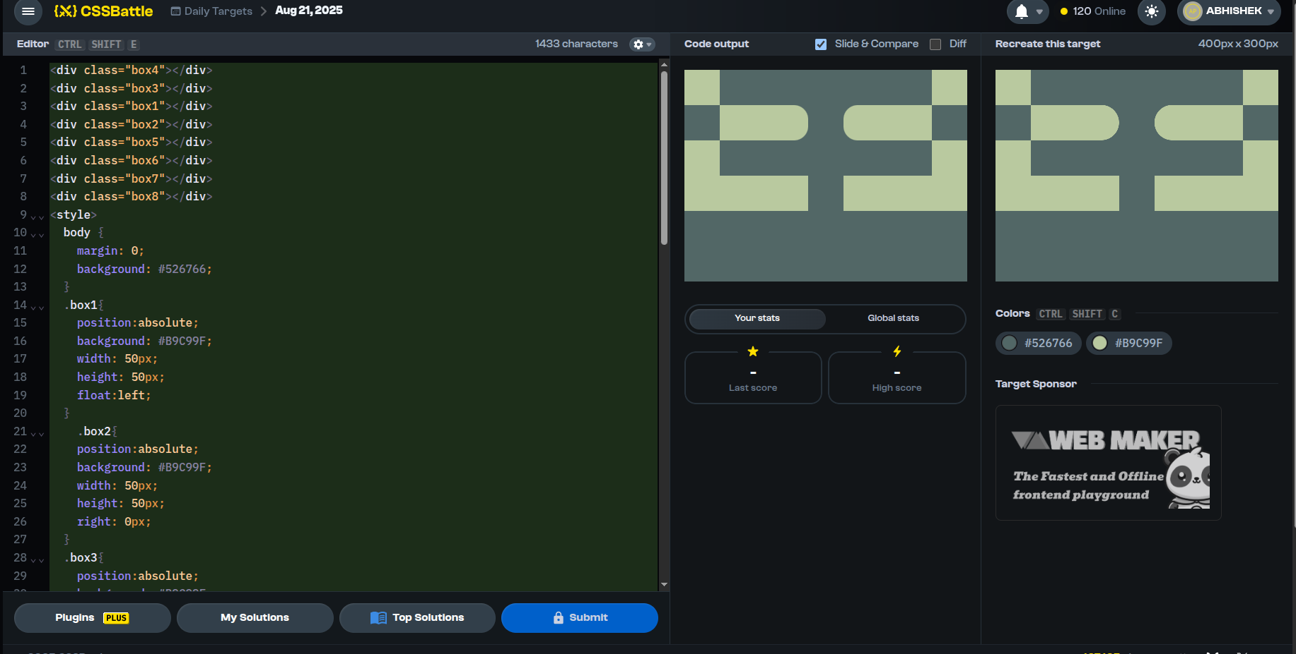

QUESTION 2
<div class="bar l"></div>
<div class="bar r"></div>
<div class="blk"></div>

<style>
body {
background: #FFFFFF;
}
.bar {
position: absolute;
top: 0;
width: 50px;
height: 100%;
background: #F88889;
}
.l { left: 80px; }
.r { right: 80px; }

.blk{
position: absolute;
top: 125px;
left: 50px;
right: 80px;
height: 50px;
width: 300px;
background: #000000;
border-radius: 50px;
}
</style>
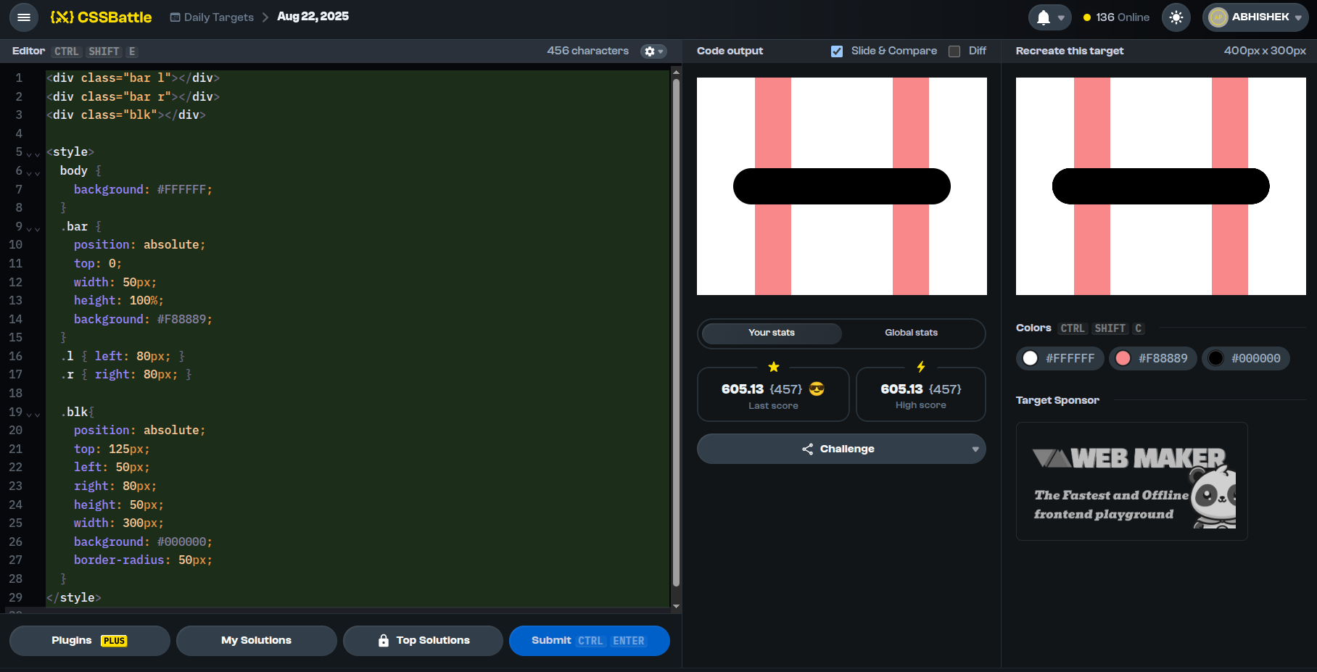

question 3
<div></div>
<div class="box1"> </div>
<div class="box2"> </div>
<div class="box3"> </div>
<div class="box4"> </div>

<style>
body {
background-color: #414B81;
}

div {
position: absolute;
width: 80px;
height: 50px;
background: #FADE8B;
top:125;
left:160;
}
.box1{
position:absolute;
height:100;
width:100;
background:#FADE8B;
top:25;
left:60;
border-top-left-radius: 60px;
border-top-right-radius: 60px;
border-bottom-left-radius: 60px;

}
.box2{
position:absolute;
height:100;
width:100;
background:#FADE8B;
top:25;
left:240;
border-top-left-radius: 60px;
border-top-right-radius: 60px;
border-bottom-right-radius: 60px;
}
.box4{
position:absolute;
height:100;
width:100;
background:#FADE8B;
top:175;
left:60;
border-top-left-radius: 60px;
border-bottom-left-radius: 60px;
border-bottom-right-radius: 60px;
}
.box3{
position:absolute;
height:100;
width:100;
background:#FADE8B;
top:175;
left:240;
border-top-right-radius: 60px;
border-bottom-right-radius: 60px;
border-bottom-left-radius: 60px;
}
</style>

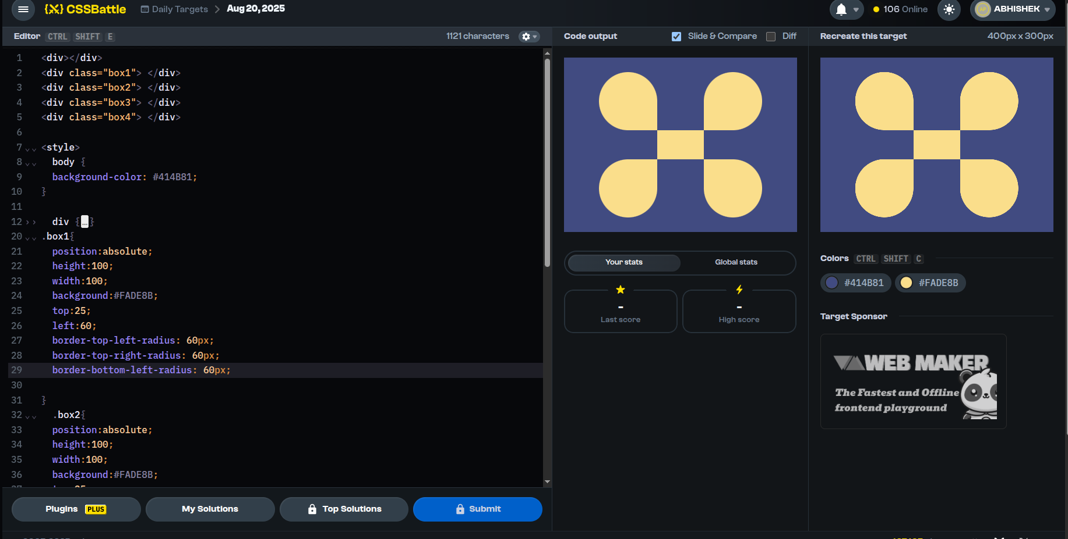

question4

<div class="box1"></div>
<div class="box2"></div>
<div class="box3"></div>
<div class="box4"></div>
<div class="box5"></div>
<div class="box6"></div>
<div class="box7"></div>
<div class="box8"></div>
<div class="box9"></div>
<div class="box10"></div>
<div class="box11"></div>
<div class="box12"></div>

<style>
body{
background-color:#FCEBEB;
}
.box1 {
position:absolute;
width: 60px;
height: 20px;
background:#DE6B67;
left:170px;
top:20;
}
.box2{
position:absolute;
width: 60px;
height: 20px;
background:#DE6B67;
left:170px;
top:60;
}
.box3 {
position:absolute;
width: 60px;
height: 20px;
background:#DE6B67;
left:170px;
top:100;
}
.box4 {
position:absolute;
width: 60px;
height: 20px;
background:#DE6B67;
left:170px;
top:180;
}
.box5 {
position:absolute;
width: 60px;
height: 20px;
background:#DE6B67;
left:170px;
top:220px;
}

.box6 {
position:absolute;
width: 60px;
height: 20px;
background:#DE6B67;
left:170px;
top:260px;
}

.box7 {
position:absolute;
width: 60px;
height: 20px;
background:#DE6B67;
left:110px;
top:160px;
}
.box8 {
position:absolute;
width: 60px;
height: 20px;
background:#DE6B67;
left:50px;
top:140px;
}
.box9{
position:absolute;
width: 60px;
height: 20px;
background:#DE6B67;
left:110px;
top:120;
}
.box10{
position:absolute;
width: 60px;
height: 20px;
background:#DE6B67;
right:110px;
top:120;
}
.box11{
position:absolute;
width: 60px;
height: 20px;
background:#DE6B67;
right:50px;
top:140;
}
.box12 {
position:absolute;
width: 60px;
height: 20px;
background:#DE6B67;
right:110px;
top:160;
}
</style>

<
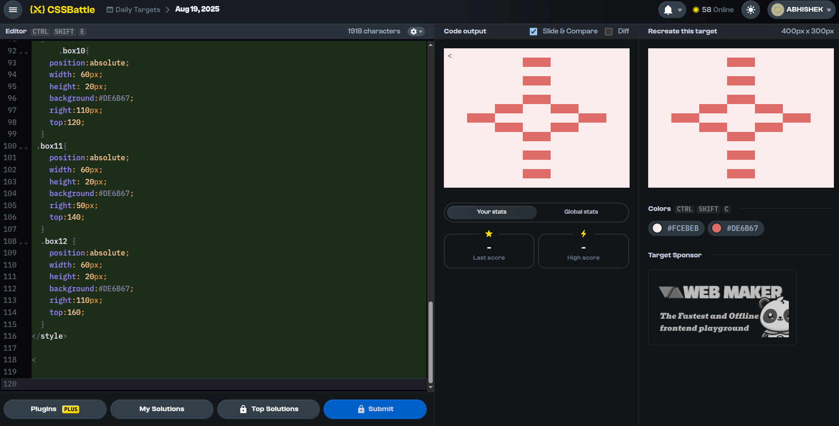
QUESTION 5
<div class="box1" ></div>
<div class="box2" ></div>
<div class="cir1" ></div>
<div class="cut1" ></div>
<div class="cir2" ></div>
<div class="cut2" ></div>

<style>
body{
background-color:#E8AD6D;
}
.box1{
position:absolute;
width: 280px;
height: 50px;
background: #3B240C;
top:90px;
left:60px
}
.box2{
position:absolute;
width: 60px;
height: 50px;
background: #3B240C;
top:160px;
left:170px
}
.cir1{
position:absolute;
width: 100px;
height: 50px;
background: #3a2206;
border-top-left-radius: 150px;
border-top-right-radius: 150px;
top:160px;
left:60
}
.cut1 {
position:absolute;
width: 30px;
height: 30px;
background: #E8AD6D;
border-top-left-radius: 150px;
border-top-right-radius: 150px;
top:190px;
left:95px;
}
.cir2{
position:absolute;
width: 100px;
height: 50px;
background: #3a2206;
border-top-left-radius: 150px;
border-top-right-radius: 150px;
top:160px;
left:240px;
}
.cut2{
position:absolute;
width: 30px;
height: 30px;
background: #E8AD6D;
border-top-left-radius: 150px;
border-top-right-radius: 150px;
top:190px;
left:275px;
</style>

